Weekly Report

Tengteng Tao

2019/08/19

Goal:

1. Manually measure the HWHM values for all the data of material MoS2 with Kperp equals 5.1 inverse angstrom
2. Plot the HWHM values vs. azimuthal angles.

Procedure:

I manually measured all the data points contained in the data set of material MoS2 with Kperp equals 5.1 inverse angstrom. Here are the plots:

In polar coordinates:

HWHM values VS. Azimuthal angles For material MoS2 with Kperp equals 5.1 inverse angstrom.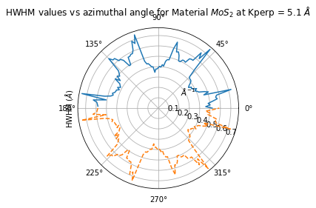

In cartesian coordinate:

HWHM values VS. Azimuthal angles For material MoS2 with Kperp equals 5.1 inverse angstrom.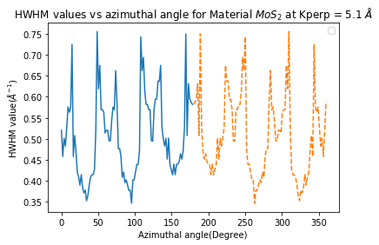

Conclusion:

We can see that the figure shows a clear symmetry for material MoS2 with Kperp equals to 5.1 inverse angstrom. I also tried to manually measure the HWHM values for material WS2 with Kperp equals 5.9 inverse angstrom, but the code kept reporting errors, and I am trying to fix it. The data I received for material MoS2 with Kperp equals 3.997 inverse angstrom is wrong, and I can not download it.